**QUESTIONNAIRE**

for the development of a technical and commercial proposal for the supply of a rail tranfer cart

|  |  |  |
| --- | --- | --- |
| Customer: |  | |
| Telephone: |  | E-mail: |
| Full name of contact person: | |  |
| Position and department: | |  |

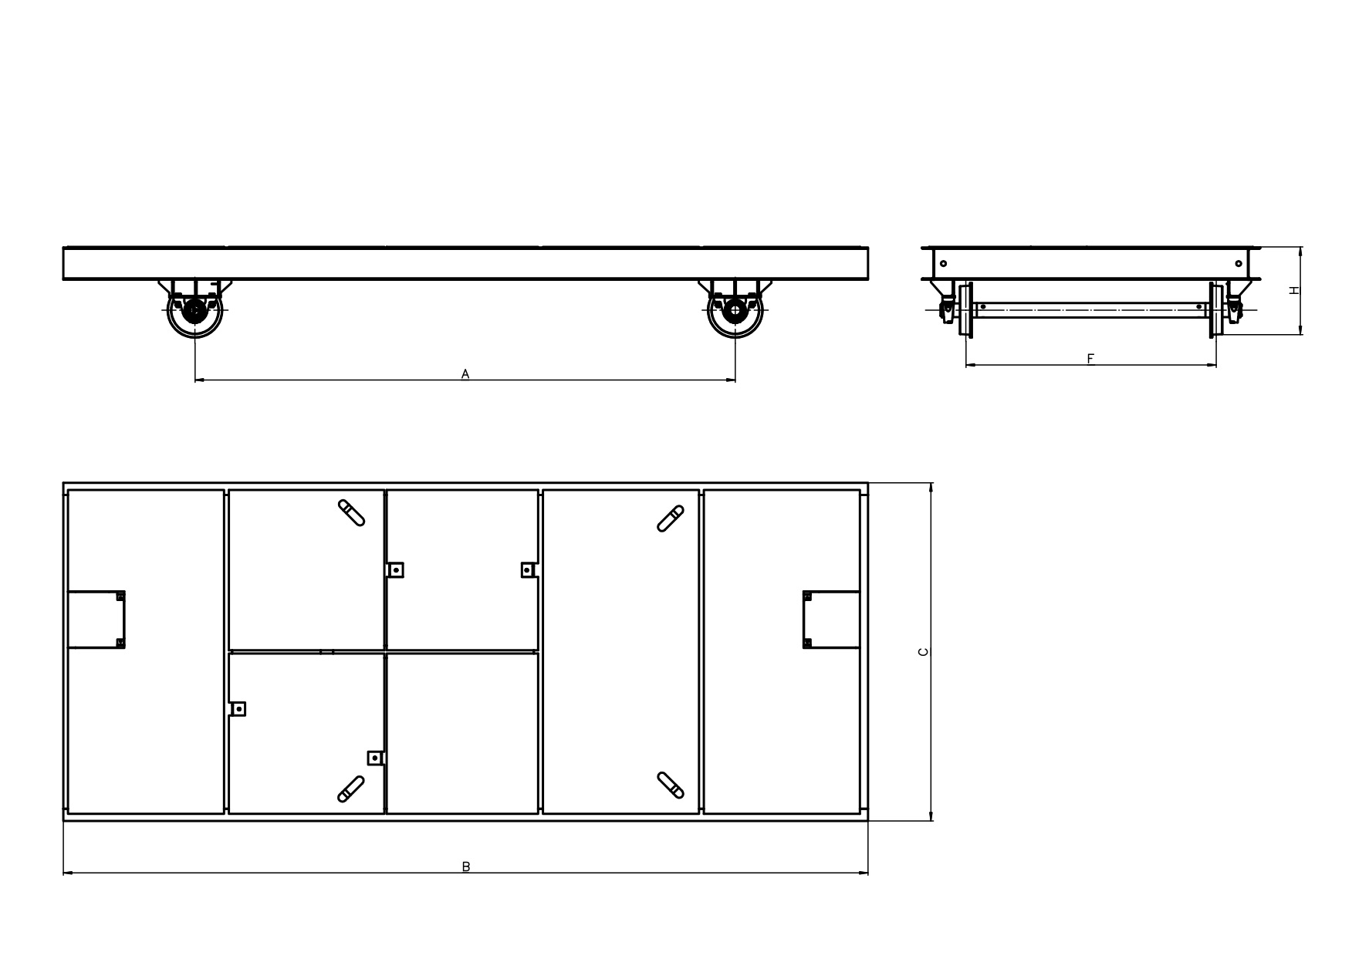

|  |  |  |
| --- | --- | --- |
|  | Load capacity of the cart, t |  |
|  | Distance between wheel axles A, mm |  |
|  | Platform length B, mm |  |
|  | Platform width C, mm |  |
|  | Track width F, mm |  |
|  | Height H, mm |  |
|  | Travel length, m |  |
|  | Drive: |  |
| from the geared motor on the cart (yes/no) |  |
| from a separate winch via an "endless cable" (yes/no) |  |
|  | Power supply type (cable, trolley, without drive) |  |
|  | Cable drum (yes/no) |  |
|  | Soft starter (yes/no) |  |
|  | Radio control (yes/no) |  |
|  | Sound alarm (yes/no) |  |
|  | Light signaling (yes/no) |  |